AP Calculus AB Name ________________________________________

Analyzing Graph Behavior Warm Up

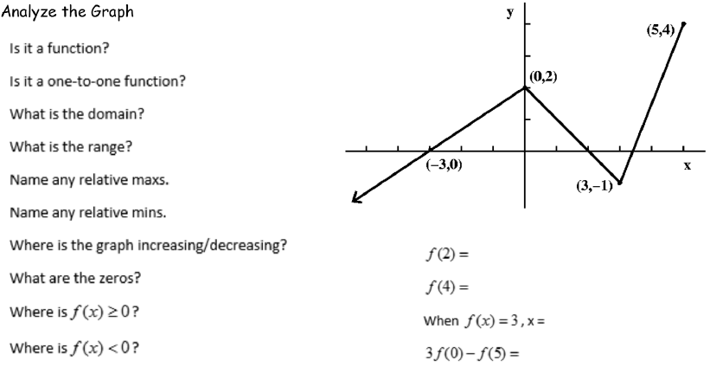

Use a graphing calculator to answer the questions below.

